CSC5802

**Coursework Documentation**

Key Commands:

Left/Right Key -> Moves to the previous/next scene

Pause Key -> Pauses/Unpauses automatic scene transition cycle, starts as paused by default

3 and 4 Keys -> Rotate the camera clockwise or anticlockwise

w/a/s/d Keys -> Moves the camera on forwards backwards and sideways

Space Key -> Moves the camera down

Shift Key -> Moves the camera up

Screenshots:

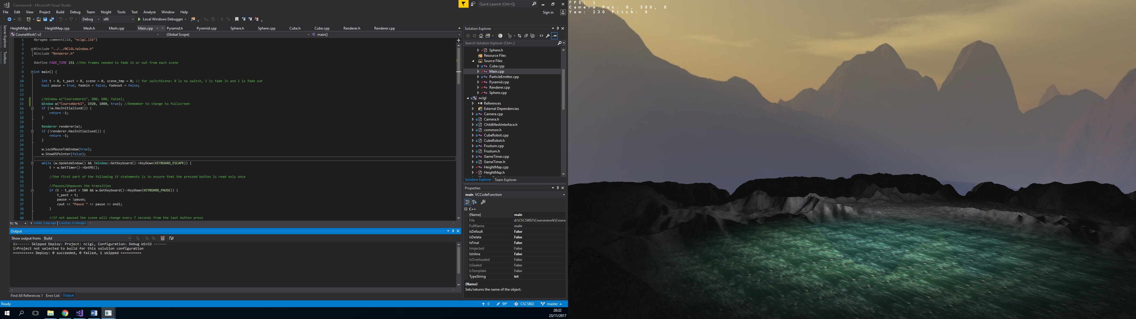

Fig 1: A scene of a lake which reflects the skybox around it.

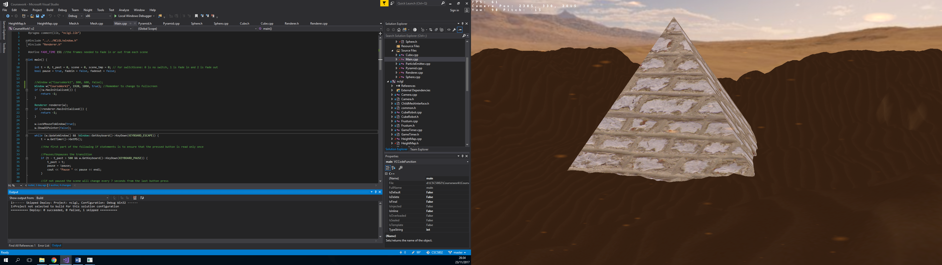

Fig 2: A scene of pyramid in the desert with particle effects flying around simulating a sandstorm, the camera also has a brown/red filter over it to give the illusion of the desert.

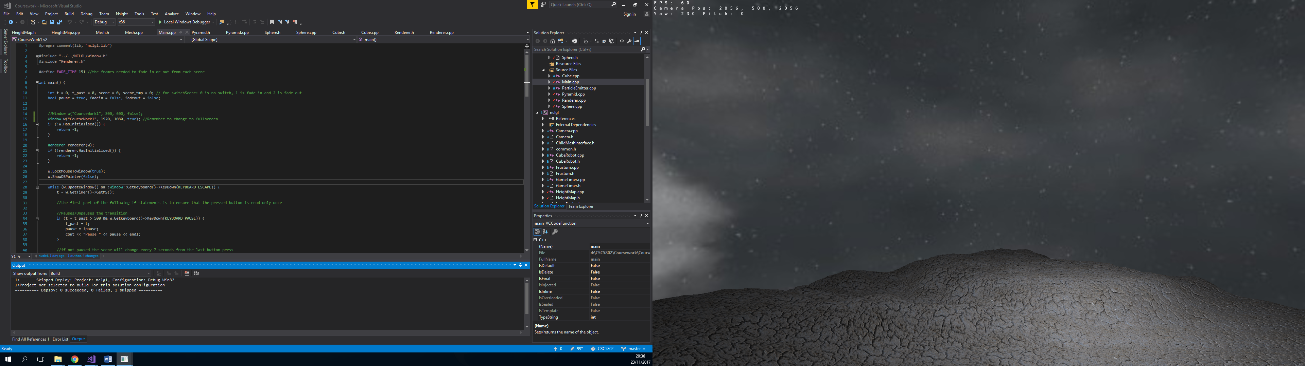

Fig 3: The peaks of the terrain slowly form over time.

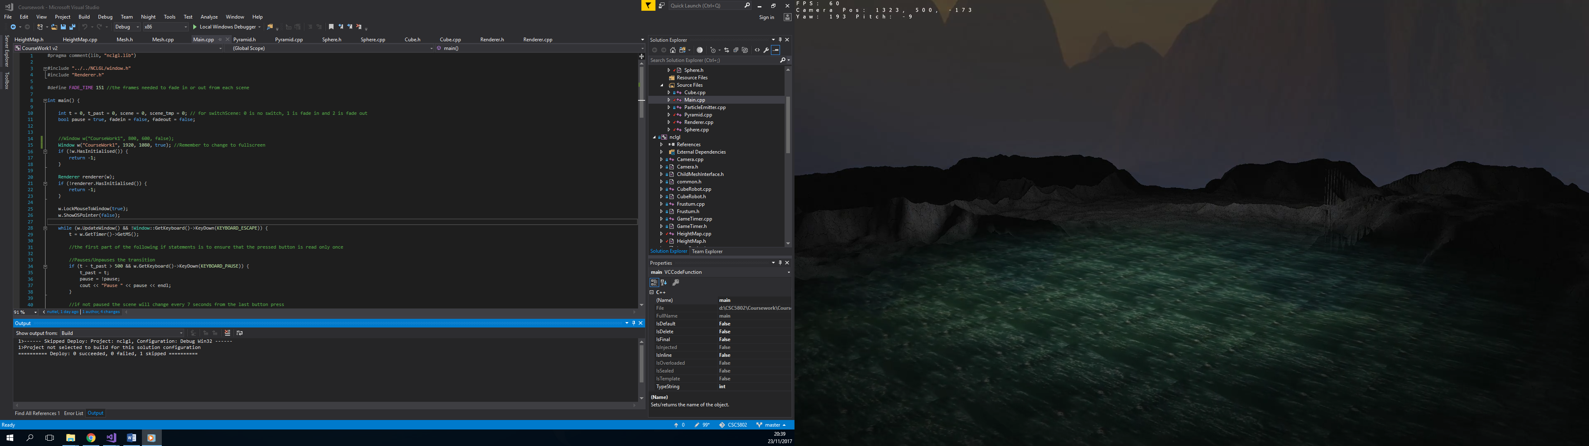 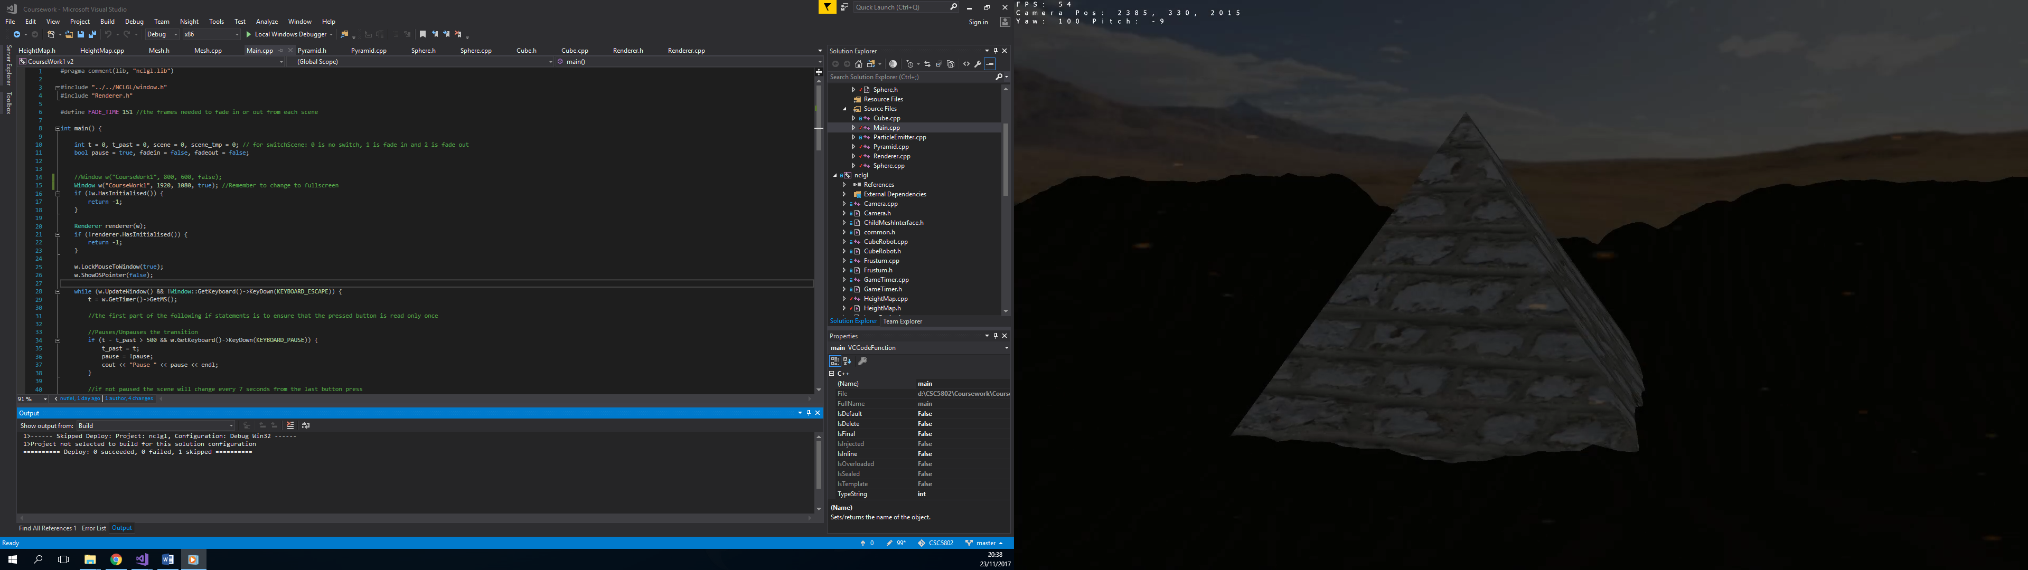

Fig 4: The transition between scenes happens with a fade in and out effect.

YouTube Link:

<https://youtu.be/AtMAzdxlEVg>

Note:

1. The video has two points where it goes black. That was when I switched back into the window from the screen recording software.
2. The controls do not work during the fade in and out duration.
3. The sources for the textures and meshes used is either in the comments above loading them or in their respective folders.